**TIME SERIES VISUALIZATION**

This project is used to retrieve the unemployment rates of various states in US over a particular period of time. Initially the data for the unemployment rates has been collected from the BLS website and filtered to get the useful data which has been stored as csv file. Later the csv file has been given as the input to the program to get a graph of all the states in US with Unemployment rate on the Y-axis and years on the x-axis

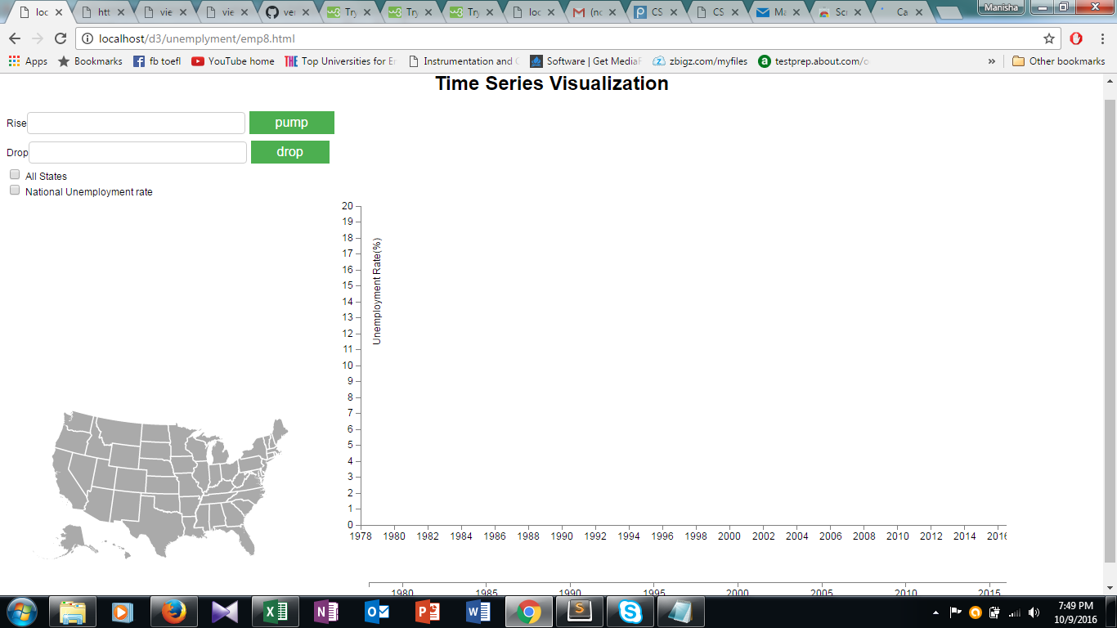

Then the map has been integrated with the program which enables the user to select a state on the map and the graph will be shown accordingly.

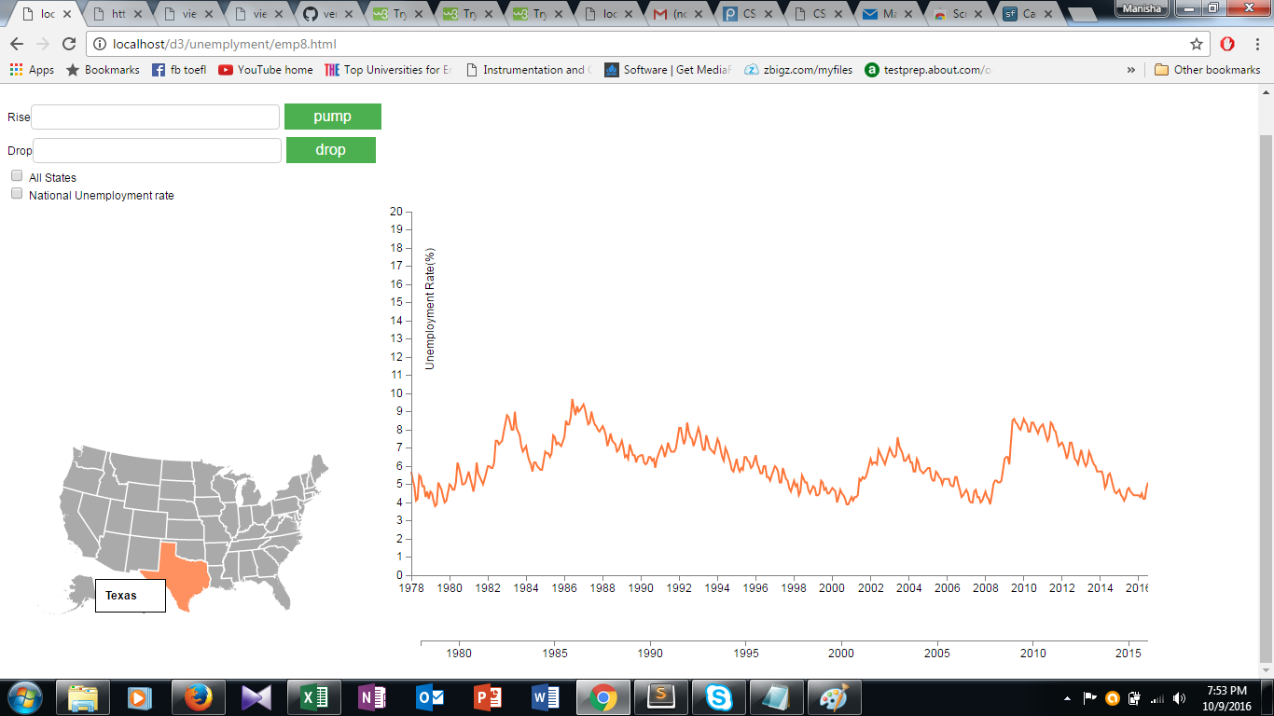

Tool tip is attached to map which enables user to identify state on the map.

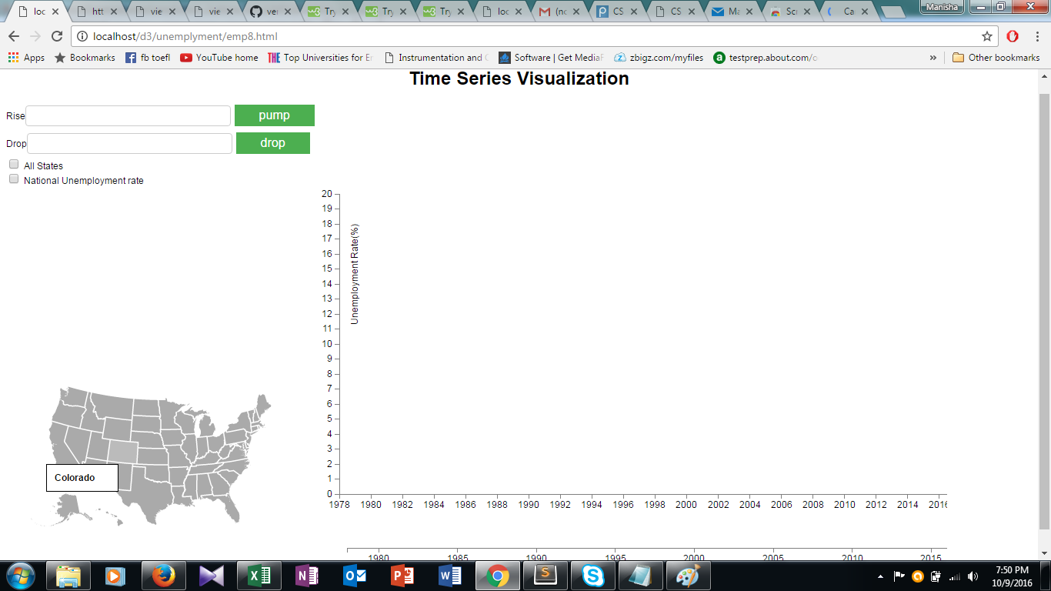

Tool tip has also been attached to the graph which enables the user to understand the graph is correctly shown for a particular state. The tool tip also contains year and unemployment rate over a point.

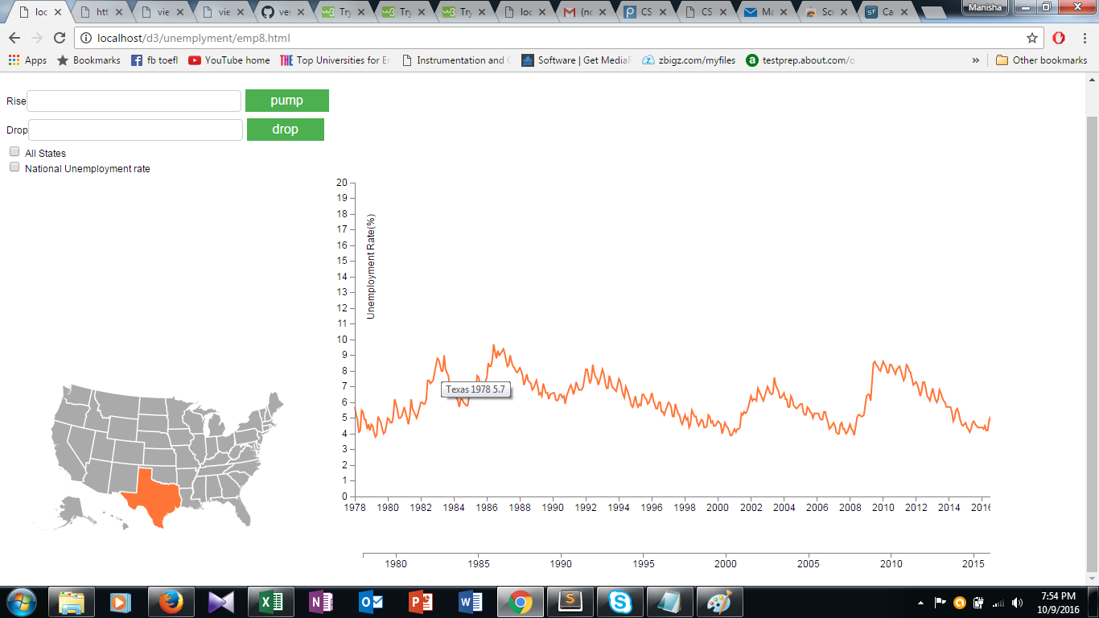

When we hover the mouse on time series the graph of particular state will be highlighted and color of all the other states will be faded. When we move the mouse out of the graph the tool tip enables to identify the neighbouring states information.

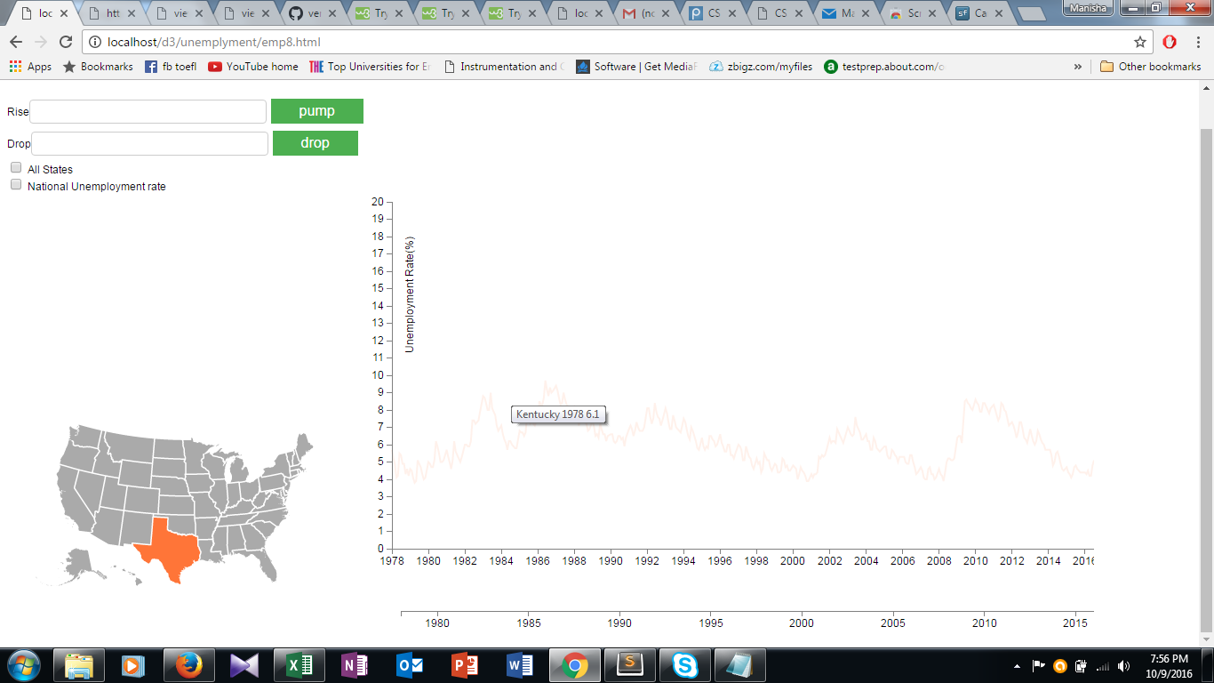

A **slider** has been implemented below the x-axis which enables the user to zoom into the time series. It also can be slided forward and backward.

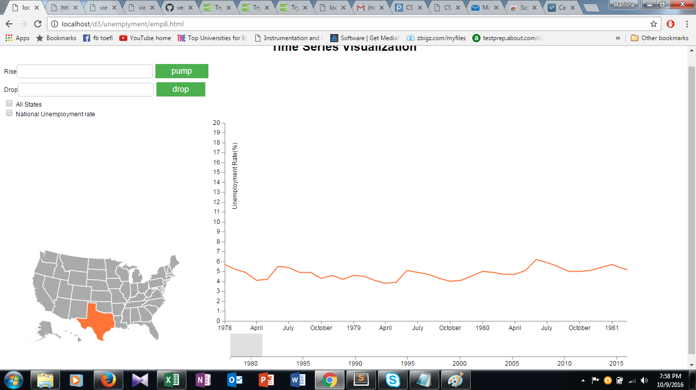

User is also enabled to select multiple states on the graph and compare the time series over various years. They can also be zoomed to get more clear insight over various months.

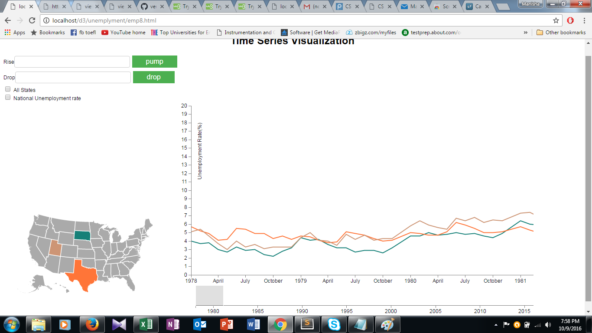

The state on the map can be selected and deselected. When the state is selected the particular state will be highlighted on map and graph will be retrieved. When the user de selects it the both the graph and map will disappear.

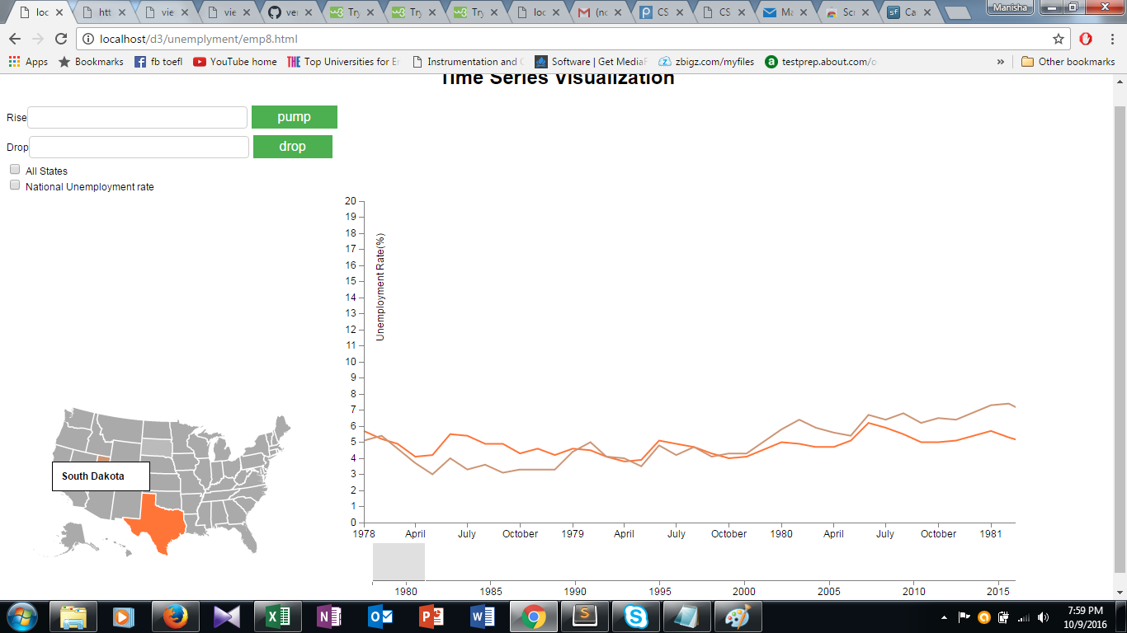

A checkbox is provided which enables the user to select the unemployment rates of all the states in the period of 1978 t 2015.

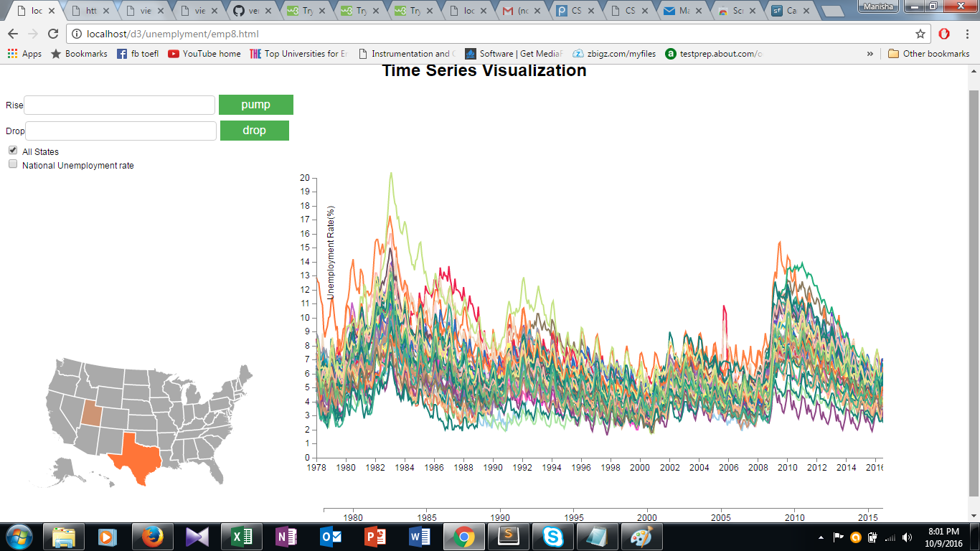

When the mouse is hovered on a particular state it gets highlighted making opacity of all the other states low.

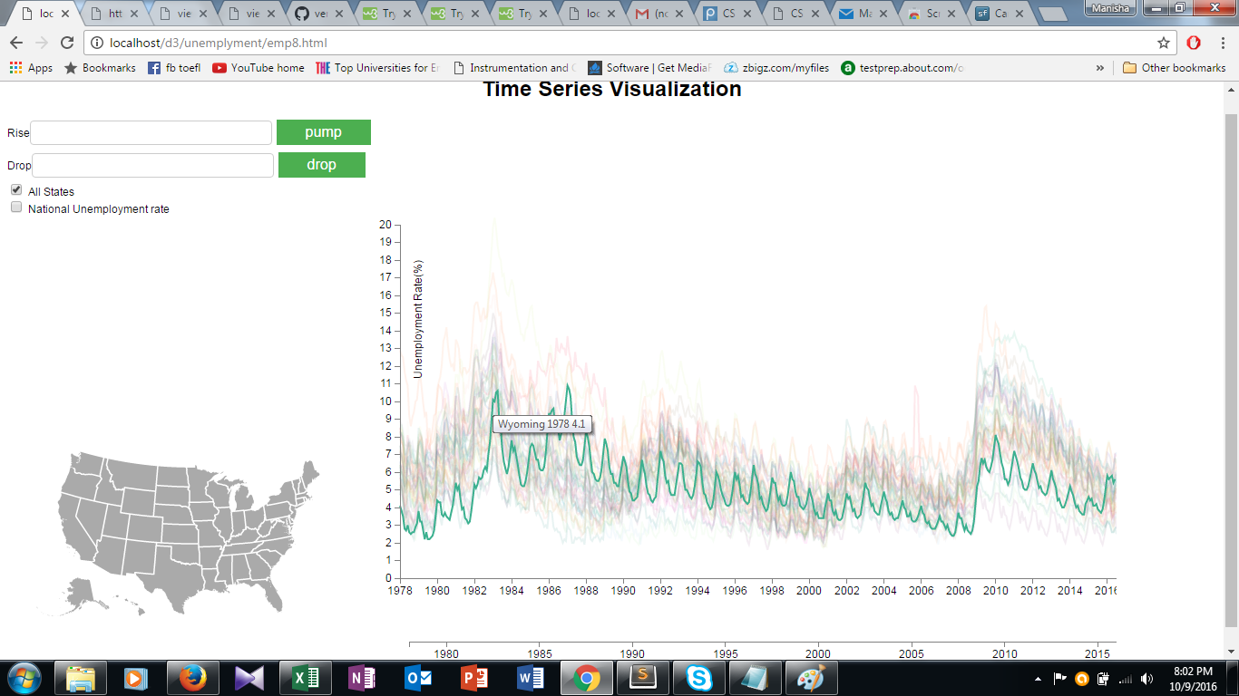

Another Check box is also provided to get the national unemployment rate over the period of 1978 to 2015.

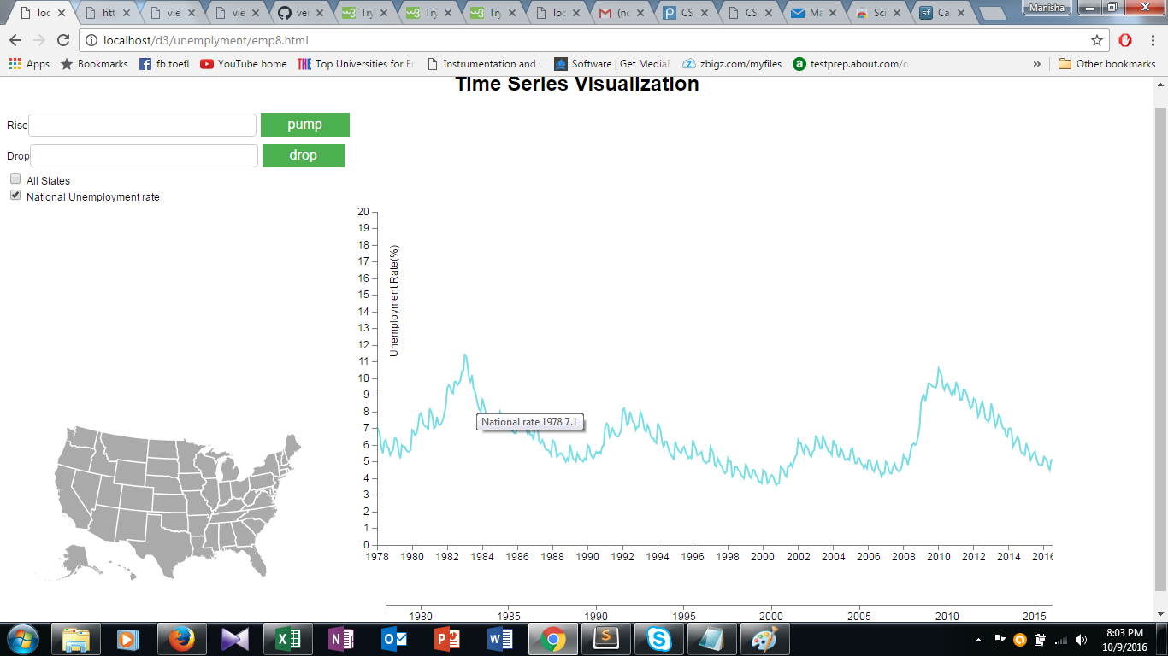

Pump button enables the user to check when there are sudden rises in the unemployment rates and the corresponding graphs will be displayed.

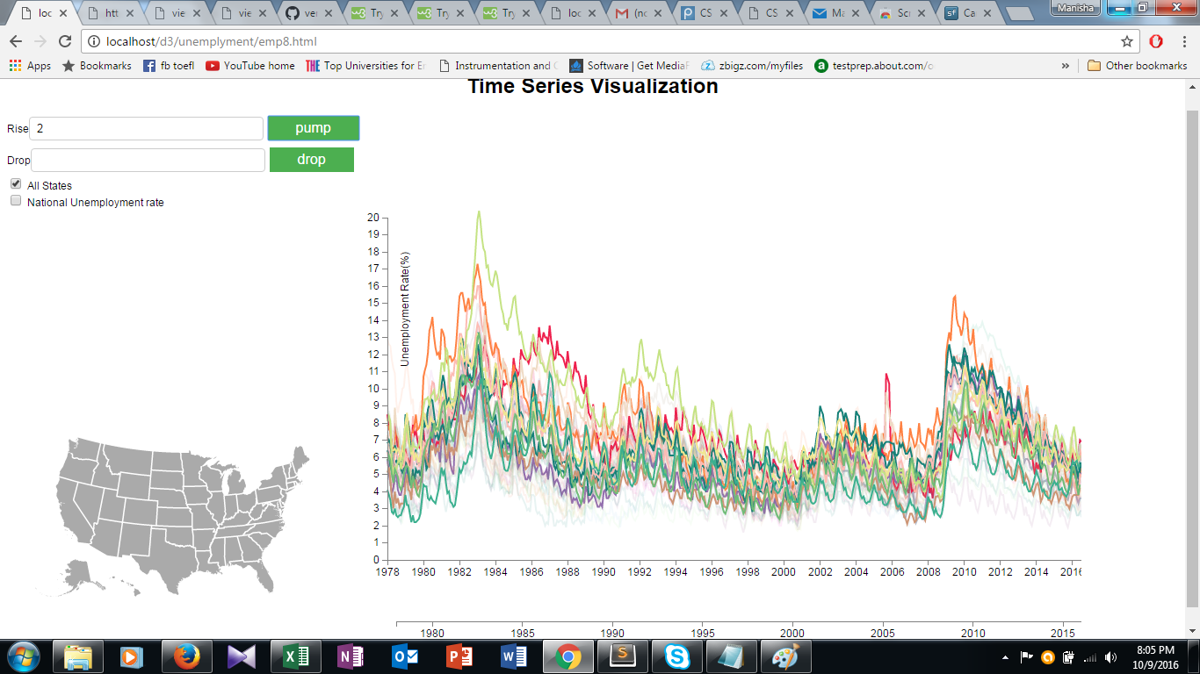

Similarly drop button enables user to check sudden drops in unemployment rates and the corresponding states graphs will be displayed.

